Unit Effect
ΔiY​=Yi1​−Yi0​
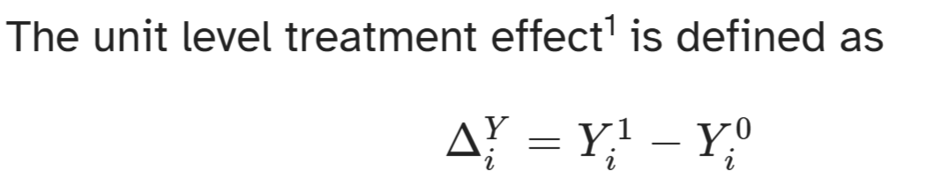
Identification assumption(s)
To identify causal effects we need the treated and un-treated populations to be exchangeable,
- stable unit treatment values (SUTVA), i.e. no interference between units & a single version of treatment and control, and
- common support, meaning both treated and untreated units exist in the population for each covariate combination (implicit)

ATE=πATT+(1−π)ATU
Estimand | Meaning | Formula
ATE (Average Treatment Effect) | Average effect of treatment across all units | E[Y₁ – Y₀]
ATT (Average Treatment Effect on Treated) | Effect for those who actually got treated | E[Y₁ – Y₀
ATU (Average Treatment Effect on Untreated) | Effect if untreated group had been treated | E[Y₁ – Y₀

RCM Components
- Treatment allocation rule (𝐷ᵢ) – decides which unit gets treatment
- 𝐷ᵢ = 1 → treated 𝐷ᵢ = 0 → not treated
- Potential outcomes – each unit i has
- Y₁ᵢ = outcome if treated
- Y₀ᵢ = outcome if not treated
- Switching equation – observed outcome Yᵢ = 𝐷ᵢ Y₁ᵢ + (1 – 𝐷ᵢ) Y₀ᵢ
Because we only see one of the two (Y₁ᵢ or Y₀ᵢ), we must estimate the missing counterfactual.

DAGS
Fork – Confounder
Chain – Mediator
Collider – Collider
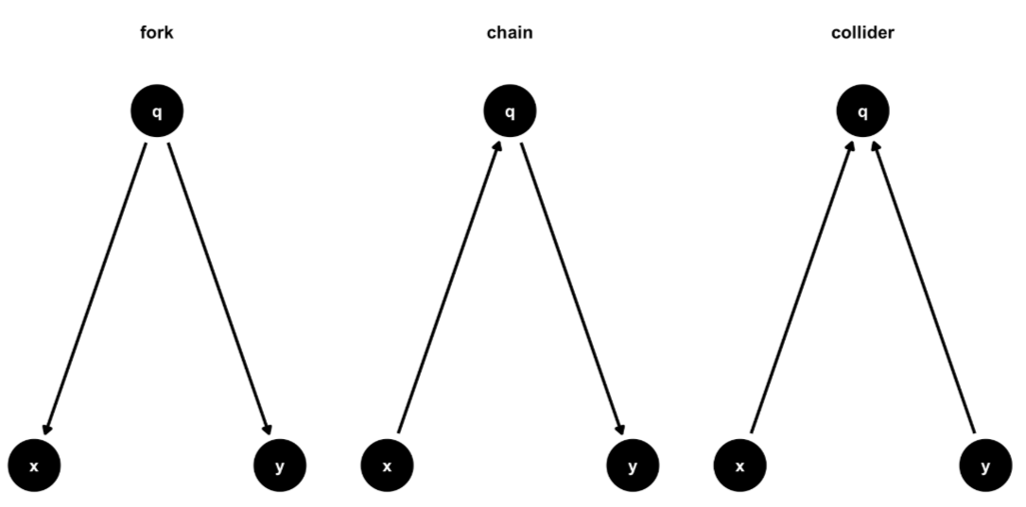

• Confounder: affects both treatment and outcome (e.g., income → education & health)
→ Must control for these.
• Mediator: lies on the causal path (treatment → mediator → outcome).
→ Helps explain how the effect occurs.
• Collider: a common effect of two causes; controlling for it can create spurious links.
→ Never control for colliders.

# Non-causal paths are also called backdoor paths.
Exchangeability holds when treatment assignment is independent of potential outcomes. The same concept is expressed in the assumption of no open, non-causal paths.

DAGs - M-Bias and Butterfly Bias
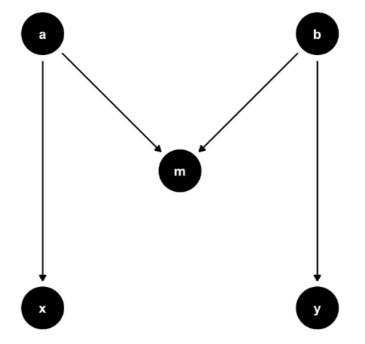

Acyclic – So No looping as you cant go back

Variable | Role | Why
D | Treatment | D is assigned as the treatment in the simulation and is the cause of Y.
Y | Outcome | Y is generated as the effect of D and W.
V | Confounder | V → D and V → W → Y, so V affects both D and Y (via W).
W | Mediator | D → W → Y: W sits on the causal pathway from D to Y.
Z | Post-treatment variable (BAD CONTROL) | D → Z and Y → Z. Z happens after treatment and is affected by Y, so adjusting for it biases the causal effect.

Summary Table
Type of Path | Example | Meaning | Should we keep or block it?
Direct causal | D → Y | Immediate effect | Keep
Indirect causal (mediated) | D → A → Y | Effect through a mediator | Keep
Confounding (backdoor) | D ← B → Y | Spurious, due to shared cause | Block
Collider | D → C ← Y | Blocks association unless conditioned | Avoid conditioning

⚙️ Step 3. What should we do with these paths?
Path type | What it represents | Should we control for it? | Why / Effect of controlling
Direct causal (D → Y) | Total causal effect | ❌ No | It’s the main effect we want to estimate.
Indirect causal (D → A → Y) | Mediation through A | ⚠️ Depends on goal | - If estimating total effect, don’t control for A.  - If estimating direct effect, do control for A.
Indirect causal (D → B → Y) | Mediation through B | ⚠️ Same as above | Only control for B if you want to isolate D’s direct path.
Confounding paths | Bias via common causes | ✅ Yes | None exist here.

#Controlling for mediators removes their contribution.

🌍 Roadmap of What I’ll Teach You Step-by-Step
Part | Focus | What You’ll Learn
1. Foundations of Causality | Why correlation ≠ causation; potential outcomes framework | Understand counterfactuals and treatment effects
2. Random vs Non-Random Treatment | Selection bias & unconfoundedness | Learn how randomization removes bias
3. Causal Diagrams (DAGs) | Drawing and interpreting paths | Identify confounders, mediators, colliders
4. Causal Identification | Back-door & front-door criteria | Know what to control for to get unbiased effects
5. Modeling & Estimation | Translating DAG assumptions into models | Use regression/matching logic to estimate effects
6. Sensitivity & Diagnostics | Checking robustness | See how unobserved bias might change results

Term | Meaning
(Y_i) | Outcome
(D_i) | Treatment
(X_i) | Confounders we control for
(\beta) | Causal effect (if model correctly specified)
(\epsilon_i) | Random noise

6. Inverse Probability Weighting (IPW)
Purpose: Re-create a randomized experiment using observational data.
- Estimate the propensity score = probability of being treated given covariates X:
$p(X)=P(D=1∣X)$
- Assign weights to each unit:
- Treated → 1/p(X) Untreated → 1/(1–p(X))
- Use weighted averages to compute the ATE.
This balances covariates so treated and untreated groups look similar—just like random assignment.
Make a balanced model
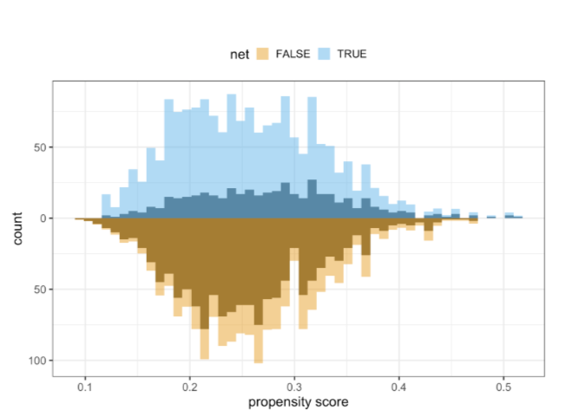

Lecture 5
Feature | Naive Bayes | SVM (Support Vector Machine)
Type of Algorithm | Probabilistic classifier | Margin-based classifier
Main Idea | Uses Bayes’ theorem to compute class probabilities | Finds the best separating hyperplane that maximizes the margin
Assumption | All features are independent ("naive" assumption) | No independence assumptions
Decision Rule | Choose class with highest posterior probability | Choose class based on side of hyperplane
Model Type | Generative model (models distribution of features) | Discriminative model (models boundary directly)
Output | Class probabilities | Class labels (probabilities optional with extensions)
Strengths | Very fast, simple, works well with text data | Works well in high-dimensional or non-linear problems
Weaknesses | Poor when features are highly correlated | Slower on large datasets, requires tuning (C, kernel)
Best Use Cases | Spam detection, text classification, sentiment | Image classification, fraud detection, complex boundaries
Training Speed | Extremely fast | Slower, especially with kernels
Interpretability | High (probabilities easy to understand) | Medium/low (decision boundary not intuitive)
Works Best When | Features weakly correlated and many predictors | Classes are separable with clear margins
Handles Non-Linearity? | Not naturally | Yes, using kernels (RBF, polynomial)
Lecture 6
Concept | Definition | Formula / Rule | Memory? | Trend? | Stationary? | Where Used?
White Noise | Pure randomness with constant mean + variance | ( X_t \sim N(0, \sigma^2) ) | ❌ No memory | ❌ No trend | ✔ Yes | Errors, shocks in models
Random Walk | Sum of previous value + random shock | ( X_t = X_{t-1} + \epsilon_t ) | ✔ Yes (depends on previous) | ❌ No (no drift) | ❌ No (variance explodes) | Stock prices, unpredictable series
Random Walk + Drift | Random walk but with constant upward/downward push | ( X_t = X_{t-1} + c + \epsilon_t ) | ✔ Yes | ✔ Yes (c adds trend) | ❌ No | GDP, population growth
Markov Process | Next value depends only on current value | ( P(X_{t+1} | X_t) ) | ✔ Yes (but only 1-step) | Depends on transition | Depends
Markov Chain | Markov process with finite discrete states | Transition matrix ( P_{ij} ) | ✔ Yes (1-step memory) | Depends on transitions | Eventually stationary | Weather models, queueing, RL

Concept | What It Measures | Does It Remove Intermediate Lags? | What the Plot Shows | Used To Identify | Typical Shape in AR Models | Typical Shape in MA Models
ACF (Autocorrelation Function) | Correlation between ( X_t ) and ( X_{t-k} ) including all indirect effects | ❌ No — includes indirect correlations through other lags | Bars showing total correlation at each lag | MA order (q) | Slowly decays | Cuts off after lag q
PACF (Partial Autocorrelation Function) | Correlation between ( X_t ) and ( X_{t-k} ) after removing effects of all lags 1…k-1 | ✔ Yes — isolates direct effect | Bars showing pure (direct) correlation at each lag | AR order (p) | Cuts off after lag p | Slowly decays

Task | Use Which? | Why?
Find AR(p) order | PACF | Direct correlations show exact number of AR terms
Find MA(q) order | ACF | ACF cuts off after q lags
Check stationarity | ACF | Slow decay = non-stationary
Detect seasonality | ACF | Seasonal spikes appear clearly

Pattern | ACF | PACF | Model
ACF cuts after q | Cut off | Tails off | MA(q)
PACF cuts after p | Tails off | Cut off | AR(p)
Both tail off | Exponential or sinusoidal decay | Exponential or sinusoidal decay | ARMA(p,q)

Model | Full Name | Best For | Key Idea | Handles Seasonality? | Handles Trend? | Data Requirements | When to Use
ETS | Error–Trend–Seasonality (Exponential Smoothing) | Forecasting with level, trend, seasonality | Breaks series into components: E, T, S | ✔ Yes | ✔ Yes | Does not require stationarity | When you want trend + seasonality modeled explicitly
ARIMA | AutoRegressive Integrated Moving Average | Complex patterns + autocorrelation | Combines AR + differencing + MA | Seasonal version: SARIMA | ✔ Through differencing (I) | Requires stationary data | General-purpose forecasting; most flexible
AR | AutoRegressive Model | Autocorrelation in past values | Today = function of past values | ❌ Not by itself | ❌ No inherent trend | Must be stationary | When PACF cuts off → AR(p)
MA | Moving Average Model | Shock effects / error correlations | Today = function of past shocks/errors | ❌ No | ❌ No | Must be stationary | When ACF cuts off → MA(q)

Pattern Type |  | ETS | ARIMA |  |  | AR |  | MA
Trend |  | ✔ Built-in | ✔ Through “I” term |  |  | ❌ |  | ❌
Seasonality |  | ✔ Built-in | ✔ SARIMA |  |  | ❌ |  | ❌
Autocorrelation |  | ✔ Indirect | ✔ Strong |  |  | ✔ Directly |  | ✔ Directly
Pure noise |  | Weak | Can detect |  |  | ❌ |  | ✔ (MA often fits noise)
Model | Stationarity Required? |  |  |  | Why?
ETS | ❌ No |  |  |  | Uses smoothing, not AR/MA
ARIMA | ✔ Yes |  |  |  | AR & MA assume stationarity; handled by Differencing (I)
AR | ✔ Yes |  |  |  | Coefficients rely on stable mean/variance
MA | ✔ Yes |  |  |  | Shock patterns only stable if series is stationary
Model | Identify Using |  |  |  | Pattern
AR | PACF |  |  |  | PACF cuts off at lag p
MA | ACF |  |  |  | ACF cuts off at lag q
ARIMA | ACF & PACF after differencing |  |  |  | Mixed tails-off patterns
ETS | No ACF/PACF needed |  |  |  | Based on trend/seasonality presence
If your data has… |  |  |  | Use
Strong trend + seasonality |  |  |  | ETS (AAA, MAM, etc.)
Non-stationary + autocorrelation |  |  |  | ARIMA or SARIMA
Strong direct autocorrelation (PACF cutoff) |  |  |  | AR(p)
Error-based correlation (ACF cutoff) |  |  |  | MA(q)

